Brits Abroad Shanghai
Annual Report 2019 -2020

Contents

Page
- President’s review of the year 3

- Membership 6

- Social 6

- Regular Activities 16

- Community Outreach 21

- Internal & External Communications 24

- Financial Report 25

- Public Relations & Marketing 26

- The Brits Abroad Team 26

1. President’s review of the year

It has been a fulfilling year and an honour and privilege to serve for Brits Abroad Shanghai. We have seen the British society which set out 24 years ago; go from strength to strength in 2019/2020. This year has brought a characteristically full and productive schedule. Following on from Social Team Leader the previous year to becoming President, I pledged to focus on three initiatives: to bring a broad range of inclusive social activities to the calendar, to promote a wider membership for families and enhance our charitable events. These goals were with the overall aim of building a stronger community for our members to enjoy. We have accomplished a lot and there is so much to be proud of, much to celebrate, much to thank people for and of course, still much to do. I hope that this Annual Report captures many of our successes, showcases much of our great work and keeps our members well-informed about the achievements we have had over the past twelve months.

I would like to extend my gratitude to the outstanding people on our committee, who work very hard on our behalf to make things happen for us. I would particularly like to thank our two Vice Presidents, Melissa Blissett and Marysia Trebley for their support, advice and encouragement this year. Marysia in her role in the Community Outreach Team, has represented us at many charity events, as well as identifying with her team the charities that Brits Abroad has supported during the year. Melissa has continued to do a super job in her joint role as Editor of the weekly bulletin juggling her other commitments outside of the committee, as well as working full time and having a busy family life. We will be sad to see Melissa leave her role and appreciate all the time she has given. I would also like to thank Christel Adriaenssen for continuing her sterling work as our treasurer; Anita Aggarwal for her magnetism and excellent work as our membership coordinator, and for her outstanding support in the social team; James Dyson for his seamless strength behind the scenes, for keeping our website up to date and our IT systems working very well; Emma Dilliway for making sure that we are all well organised in her role as secretary; Caz Johnston as coordinator for sourcing and negotiating our discounts; Vidhya Nagendran in our public relations role who has ensured we stay firmly on the Shanghai map; Bonita Frost as Social Coordinator, for making sure our social calendar is action packed and whom I would especially like to wish all the very best to for the future, we will miss her very much. We are really pleased and exceedingly fortunate to have the lovely & brilliant Pam Gray who has agreed to continue as our proofreader.

I am especially proud of the large range of events and activities that Brits Abroad has facilitated this year for our members. The social calendar has been extremely busy with routine events such as May-I, Mahjong, Coffee Mornings, the Photography Club, the Book Club, fitness and historical Walks. Thanks to our organiser Gill Knight, there have been increasingly popular quiz nights, since the change in our format and venue from the Park Tavern to the Camel, with our charismatic quizmaster Ned Kelly. There have been popular visits to gardens and parks, shopping trips, creative workshops such as the pottery and jewellery making workshops. There have been annual fixtures; the one-off big events such as the Easter Brunch, Ascot Day, Breast Cancer Think Pink Lunch, the Christmas Party, and a collaborative International Women’s Day event. Our change from Morning Tea to offering a variety of venues for our Coffee Mornings has gone very well and has been well received by our members. It is also lovely to see some new events on our calendar; weekend brunches for all the family, yoga, facilitated by Vidhya, Thai & Indian cooking lessons from Annie and Parul, night cycles, and afternoon teas. The 10k Any Day monthly fitness walk and the new craft activities have all been well attended with prompt sign ups.

Thank you to everyone who has helped with the setting up and running of these events, and a special thanks to Emily F and Sigrid B for the Photography Club, Kellie H for organising the very informative historical walks, Sigrid for facilitating the monthly 10K fitness walks, Tracy D and Gill D for keeping the May-I team at large, Catherine H-C and Candia A and the Book Club, Karen C and the Mahjong team, Gill K for our quizzes, Anita A and the coffee morning team, Bonita and the social team for many of the social events, Lucy H & Anita for leading the phenomenal Breast Cancer charity event, and Ros S for organising the Xmas Party which has become a firm favourite on our calendar.

An important part of our work this year has been the Community Outreach. I am delighted to report to members that this year, Brits Abroad has supported the following charities; Heart to Heart, Shanghai Baby Home, Shanghai Young Bakers, Shanghai Sunrise and More Than Aware. Our donations in 2019/2020 have totalled RMB 97,100. There was also the outstanding collection of clothes for Heart to Heart at the Christmas Party too. This is a fantastic achievement and on behalf of all our charities, thank you.

We have also seen some improvements in recent months with our discounts programme. Caz has been working hard to develop our range of discount providers and our website can now insert discount codes for our members to use. James Dyson has been working with Philip Crispin to update our website further.

Brits Abroad Shanghai continues to liaise with the British Consulate and with the British Chamber, and we have enjoyed excellent relationships with other expat associations. We welcomed the opportunity to showcase our organisation at some of the international schools’ open mornings, where we recruited a significant number of new members.

Our priority for the coming year is to further develop our membership subscription and hopefully regain a stable membership. We are also always seeking to recruit members to lead events or support at events, as well as lead on the committee. We encourage you to join in with our ever-evolving club in any way you can and experience all the purpose & fun of being involved.

I have thoroughly enjoyed my time as President of Brits Abroad Shanghai, and I am deeply proud of all that has been achieved. Without fail, when it is time for people to move on, they unreservedly say that Brits Abroad has been deeply important to them and they will remember us with great fondness. I hope you feel the same and I trust that you will enjoy reading this Annual Report.

With thanks to all our members for your support.

Selina Ruscoe-Price
President

2. Membership

The calendar year of 2019 saw a total of 368 members. This breaks down into 148 families consisting of 265 adults and 103 children. We have maintained 70% Full Membership (British) and 30% Associate Membership keeping in line with our constitution.

The membership fee remained at RMB 300 per family for the year. For new members who joined after 1st July, the fee was RMB 200. We gave a special offer of RMB 100 from our Meet and Greet Coffee Morning in August and continued it until 29 November when, at the Quiz night, we started renewals for 2020. From the Quiz Night on - any new members who signed up were signed up for 2020 and in effect got an extra month of membership so they would be encouraged to join and enjoy our events.
Membership sign ups were available at almost all events including Meet and Greet Coffee Mornings, Kee Club Coffee Mornings, Quiz Night, May-I, Easter Sunday Brunch, etc.

Anita Aggarwal
Membership Coordinator

3. Social
Our social calendar was filled with numerous games, clubs and walks. In addition, lots of new fun events were added in 2019 and January 2020. There was a host of weekly events, such as Photography Club, Mahjong, Book Club, 10k and Informative Walks, May-I and the return of our Monthly Meet and Greet morning coffees. We introduced new events such as Cooking Classes, a Shanghai Night Cycle, Weekend Family Brunches, Afternoon Tea and increased the frequency of our ever-popular Quiz Night from quarterly to monthly. Not forgetting our very special charity luncheon events such as IWD, Ascot, Breast Cancer Awareness and our infamous Christmas Party.

Bonita Frost
Social Coordinator

Easter Brunch

Our Easter Sunday Brunch, including an Easter egg hunt for our younger members, was held at Isola in the IFC Mall in Pudong. It was a warm gathering of our members and families overlooking the Oriental Pearl Tower. An area at the restaurant was reserved for our members and the menu was a selection of starters from the buffet, a choice of main course, a selection of desserts plus tea and coffee. Since we met the minimum number as desired by the restaurant the service charge of 10% was not applied. At the start, our members mingled on the terrace and inside the restaurant, and then seated themselves to enjoy the brunch. It was well appreciated by all who came.

Ascot Lunch

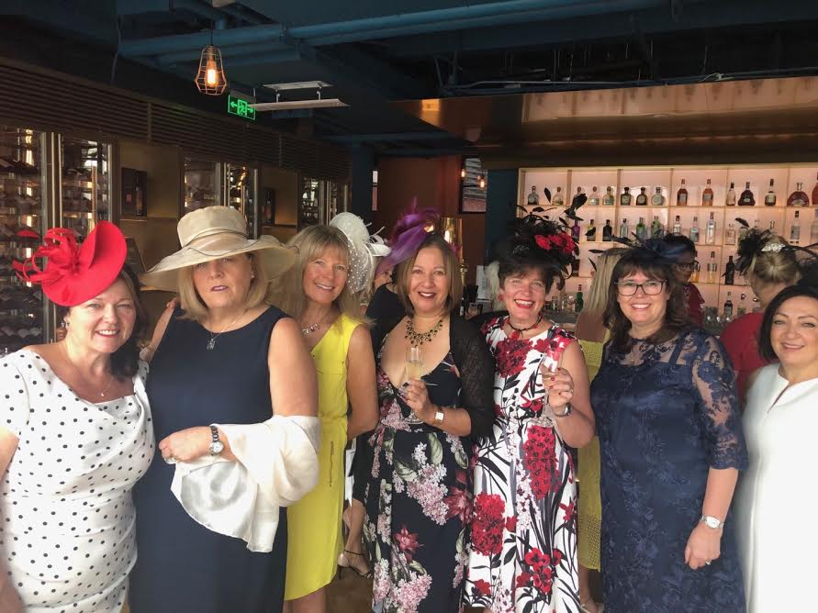
Another successful annual Ascot charity lunch was held in June 2019 at Kathleen’s in Puxi. A tasty set menu included a glass of fizz on arrival and wine with our meal. We had a great turn-out and everyone looked very elegant dressed for ‘Ascot’. The prize for the best hat/fascinator went to Sarah Sellars.
We had some amazing raffle prizes and raised RMB 12,700, which we topped up to RMB 15,000 and donated to H2H’s rural schools’ sports equipment program.
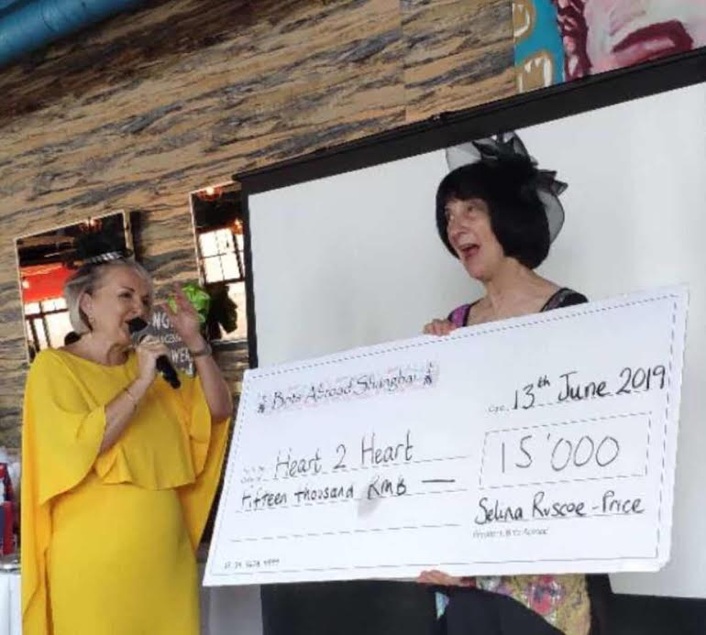
Here is an extract from the letter of thanks we received from Karen Carrington. “The money raised will definitely be put to good use with the sports packages it will be put toward. Schools in rural China need a lot of help – academically and in terms of athletics – if the children are to grow up anywhere near the par of their counterparts in Chinese cities (much less internationally). Your donation will not only help them catch up, it will make the children stronger and happier”.
Breast Cancer Awareness
We hosted our annual charity Breast Cancer Awareness Luncheon on Friday 18th October 2019. This event took place in the large dining room at ROOF 325, situated on the rooftop of the Shanghai History Museum in the heart of People’s Square. We were able to use the terrace and enjoy the views and the sunshine. The event was a great success attended by over 80 people who enjoyed a three-course meal and wine. The food was delicious and many guests sent their compliments to the Chef.
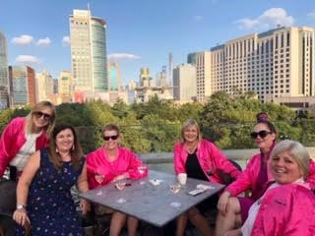
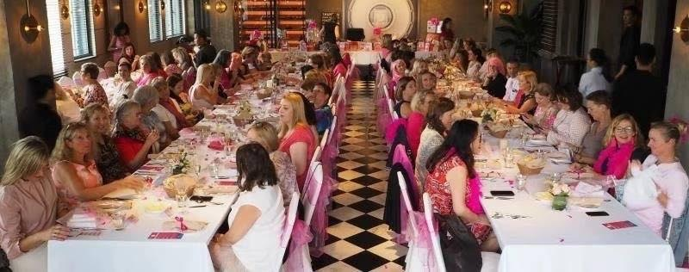
Our theme was ‘pink’, and the dining room looked marvellous, as did all our attendees. Our guests were offered the opportunity to play games and purchase raffle tickets for the prizes and bid in the auction. They were also given relevant and useful information to take away. They enjoyed a fantastic pink-themed social event and had fun whilst raising funds for a great cause. Our raffle was a huge fundraiser and we had donations from over 40 organisations and members, and for this we are very grateful indeed. We had a fabulous range of gifts and prizes and a spectacular auction prize. A pink goody bag was prepared for each attendee which contained treats and relevant information to take away. We were very pleased to welcome guests from The German Club and Shanghai Expatriate Association. All proceeds from the luncheon and fundraising events in the month of October 2019 were donated to More Than Aware. We were able to present a promise of the money to the beneficiary’s representative, Suzanne Carlton at the event. The money raised at the Luncheon was a record high and double the amount that we have raised at previous events. The total raised was RMB 30,722, which we topped up to RMB 35,000 and we have been informed that this will fund 15 women.

Afternoon Tea

Afternoon Tea proved to be a great success with our members. In July it was held at the Swissotel Grand where attendees enjoyed a delicious selection of savoury snacks and elegant sweet treats, with a surprise glass of fizz included too. We were tucked away in a cosy corner of the hotel lobby, seated in crushed velvet chairs and were serenaded by a wonderful lady vocalist, playing a grand piano.
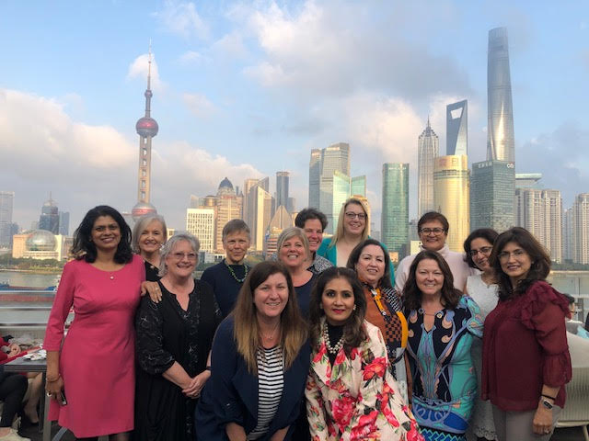
In November this event was held at Pop, 3 on the Bund. An elegant affair was had by all, enjoying a quintessential afternoon tea. This venue is simply divine and occupies the east terrace of the rooftop with great views of Shanghai‘s famous skyline inspired by Miami’s 1950s cocktail bar. The breath-taking views over the Huangpu River and the Pudong Shanghai Skyline is the perfect backdrop location for photographs. Our members thought this was a perfect place to have a return visit with family and friends right in the heart of Shanghai for lunch, afternoon tea, cocktails or dinner.

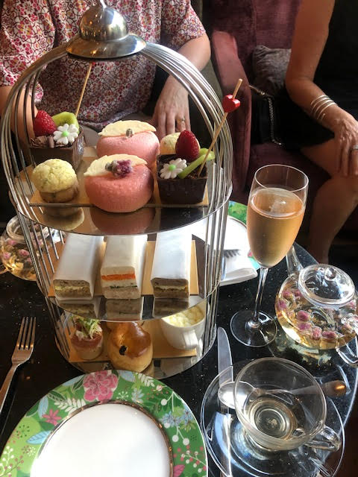
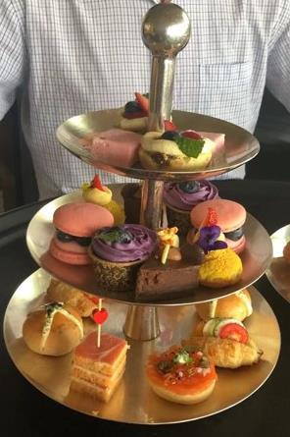
Marysia Trebley wrote “The egg bun and scone were my favourites. I think I wore more of the marshmallow than I ate, covering myself in icing sugar. I loved negotiating and trading cakes with my new-found friend Eera. It all went down a treat with good old-fashioned tea. Great company, laughter and banter.

Meet & Greet Coffee

After carrying out a survey of our members’ preferences, we re-introduced a casual monthly coffee morning alternating between Puxi and Pudong. This is a sign-up event and has been very well attended. It’s an opportunity to chat in a relaxed environment and really get to know other members. We are catered with a selection of teas and fancy coffees and a simple snack for our mid-morning gathering. We have been welcomed at the Press, Bread Etc, Kathleen’s Bistro and our members particularly enjoyed our Meet and Greet at Cotton’s, where we sat outside and enjoyed the pleasant weather in their open courtyard, whilst shopping with the highest quality of vendors. We will continue to investigate new venues around Shanghai and alternate venues between Pudong and Puxi.

Summer Social at Hooked
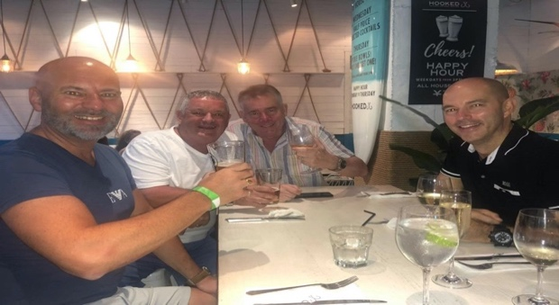
Our Summer Social was held at the popular restaurant “Hooked” at Found 158. It proved to be a big hit with many of our members and their families.
Attendees enjoyed a delicious lunch along with refreshing summer drinks.
It was a lovely way for people to catch up with friends and make new ones after the summer holidays.

Cookery Demonstrations
We were thrilled to be able to introduce Indian cooking demonstrations from two of our very own members. We were invited into their homes to watch Indian ladies cook Indian food.
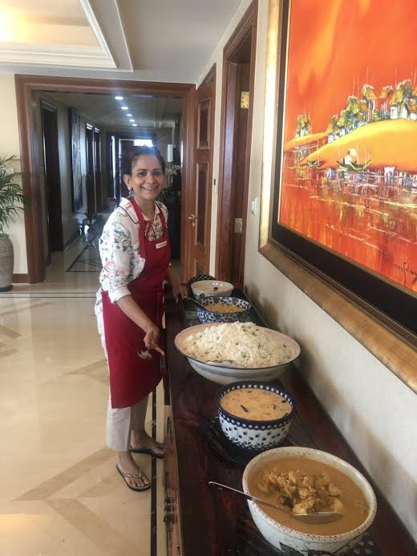
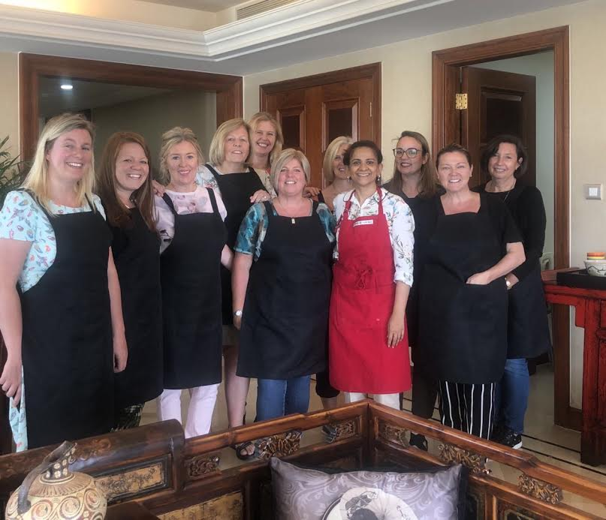
We were welcomed into the homes of Susan George in May and Parul Dasgupta in September. Both their homes were beautifully decorated with many cultural pieces. Both ladies have a flair for cooking and love to entertain. We experienced the delicious cooking from Susan's hometown of Kerala in South India and Parul’s delicious dishes which were a mix of two cuisines from the North & East as Parul hales from the North and her husband the East.
We joined each lady in their home kitchens, where we watched them demonstrate several dishes, giving us all their cooking tips and tricks. The attendees then sat down together around their dining room tables and enjoyed both of these magnificent feasts.
Members were given recipes and spices to recreate the dishes at home. We truly appreciated Susan and Parul’s time, talent and expertise.

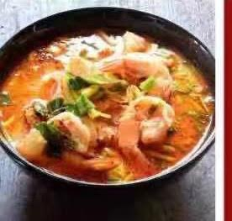
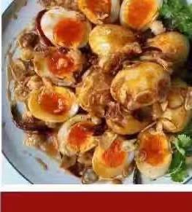
We also got the chance to experience two Thai cookery lessons with Annie, at which attendees were shown how to cook Pad Thai, Thai Spring Rolls, Tom Yum Soup and Crispy Eggs with a tamarind sauce.
After the demonstrations, our members got to sit down together to enjoy the food and everyone agreed that it was all delicious.

Tea at The Kee
The KEE Club, a private club on Huaihai Zhong Lu in Puxi, was chosen to host our monthly Morning Tea - a true traditional British look in the Twin Villas and the feeling of a touch of home. We welcomed our members, both returning and new to the elegant KEE Club where we enjoyed a delicious morning tea of delicate sandwiches, croissants, fruit and of course a traditional scone with cream and jam. We were hosted in the beautiful eclectic Red Salon which displays spectacular contemporary and modern art which is changed every few months.
Our members also enjoyed a guided tour of the Kee Club in all its splendour, they particularly liked the Gentlemen’s Smoking Room with vintage motor car and clothing memorabilia and the fireplace which is adorned with the front slice of an old Aston Martin racing car. We welcomed representatives from the charities we support and presented donation cheques.
With the request from the Kee Club for a higher turnout or a higher cost to our members, the committee decided to re-introduce a casual meet and greet monthly coffee and an Afternoon Tea event at various establishments in Shanghai.

Night Cycle

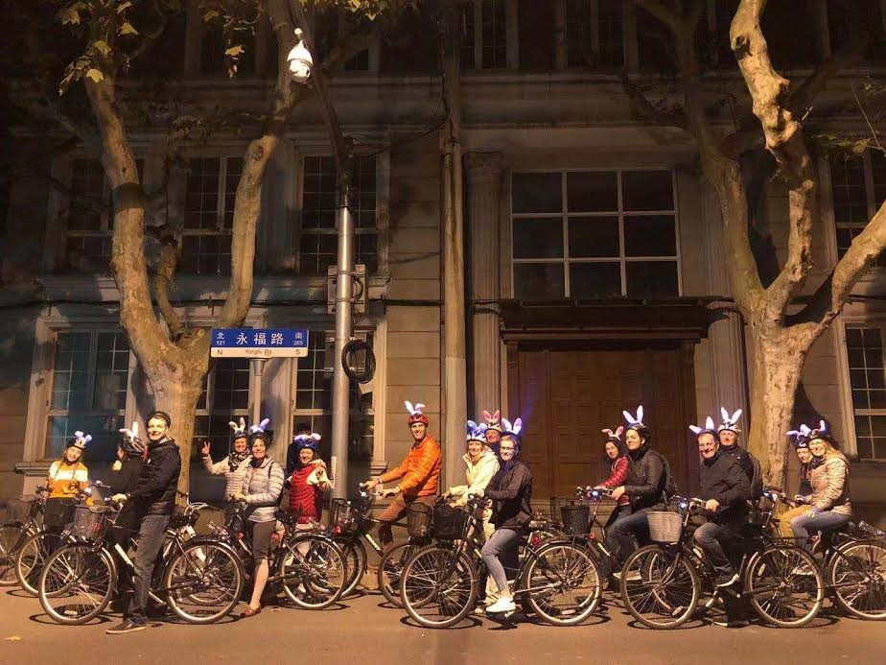
In November we organised a new event – a guided night cycle. The event kicked off at 7:15pm and bike and helmet hire were available. We had great fun cycling through the Former French Concession, old Shanghai alleyways, Yuyuan, East Nanjing Road, The Bund and People’s Square, ending up at the Shanghai Grand theatre.

Yoga Workshop
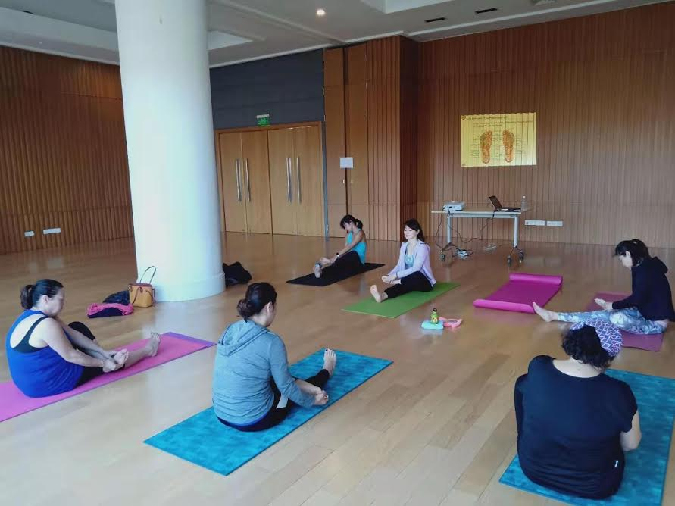
This was another new event, held in November, and run by our very own member Vidhya Nagendran. Vidhya has been practising for more than a decade and held this event at Green Court 2 Clubhouse on Biyun Road. 6 enthusiastic ladies took part and it proved to be an invigorating and relaxing experience with everyone looking forward to more workshops in the future. Future events will be suitable for beginners and anyone aged 8 and above, giving them great benefits and increased flexibility.

Indian Brunch

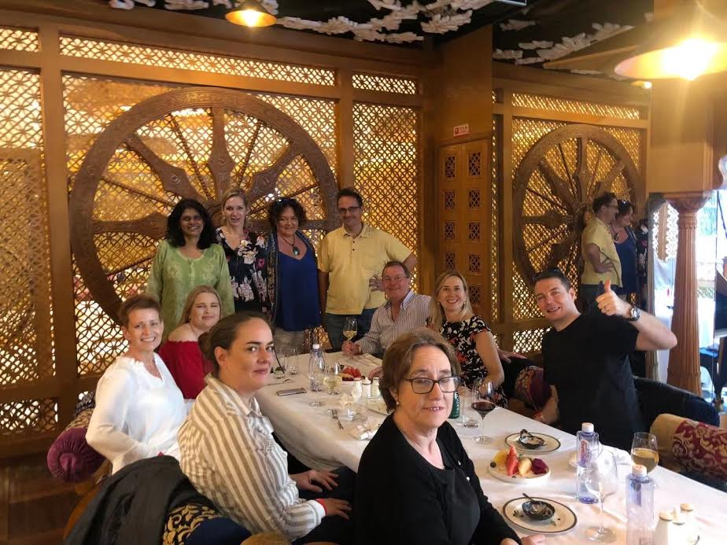
Based on feedback received from our members to have more weekend events where families can also be involved, we organised a Sunday Indian Brunch in November at Tandoor which is a Michelin BIB Gourmand Star restaurant. Chef Sanjay Tyagi laid out a lavish variety of Indian cuisine. To accompany the Brunch we had several drinks package options - a wine and beer package, a premium alcohol package, special rates for children and a without drinks package. The brunch alcohol package was a free flow for 2$½$ hours after which there was a happy hour discount on the beverages. The nibbles and appetisers were laid on the table, and the mains and desserts were served buffet style giving members the opportunity to enjoy the spread. The event was very popular and we received very positive feedback about the venue, staff and food.

Christmas Party

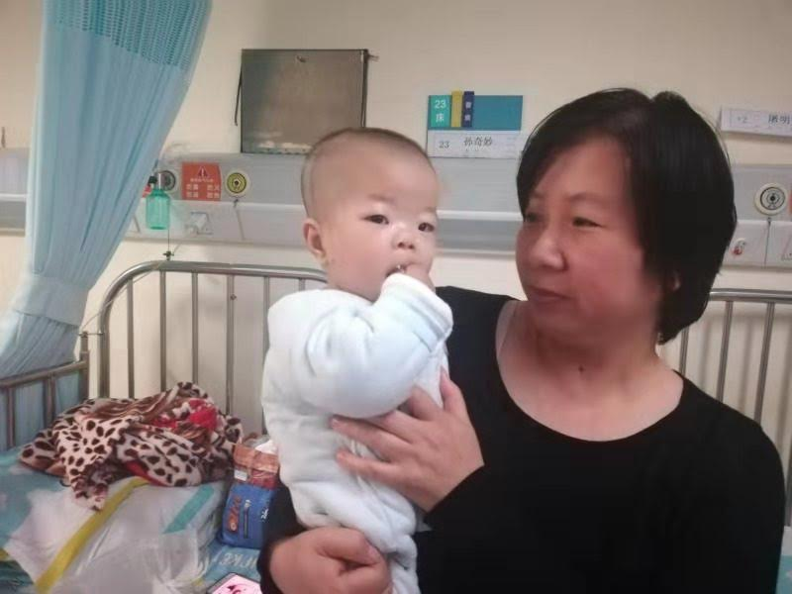
The Christmas party, as always, is the highlight of the Brits Abroad social calendar. This year it was again held on the 37th floor of the Four Seasons Hotel, which for the third year, proved to be an excellent venue for our party. The food and wine were delicious and Thomas the DJ did a fabulous job of keeping us on the dance floor with some brilliant tunes. One member said “the Brits Christmas Party was amazing – the best party of the year – as always. I don’t know how you all put it together so well, but you do….and I’ve gone to all of them over the 10+ years I’ve been in Brits.” We raised an impressive RMB 12,100 for Heart To Heart which helped baby Sun Qimiao to receive the heart surgery she desperately needed. She will have a 6-month examination after the surgery, but it is anticipated that she should be able to be taken off all heart medication at that time and go on to lead a normal life. Thank you so much for everyone who attended the party and made this possible.

Jiading Wisteria Park

In April we visited Jiading Wisteria Park on Bole Road. The park, one of only three wisteria parks in the world, was well worth the visit. The cascading wisteria was spectacular and the scent amazing.
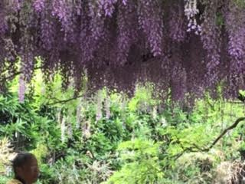
The park opened to the public in 2000 and was built to celebrate Jiading's friendly relations with Wake Town of Okayama Prefecture in Japan. It combines the characteristics of both Chinese and Japanese gardens. The park covers 10,000 square metres, has 28 varieties and over 100 wisteria trees. We visited in April but May is just as good.

Pottery Workshop
Our members had so much fun at the Pottery Workshop which was held at Ceramic Pottery on Taikang Road. They all got very messy and made lots of interesting pieces which then went on to be fired and delivered to their homes.

Gin Tasting

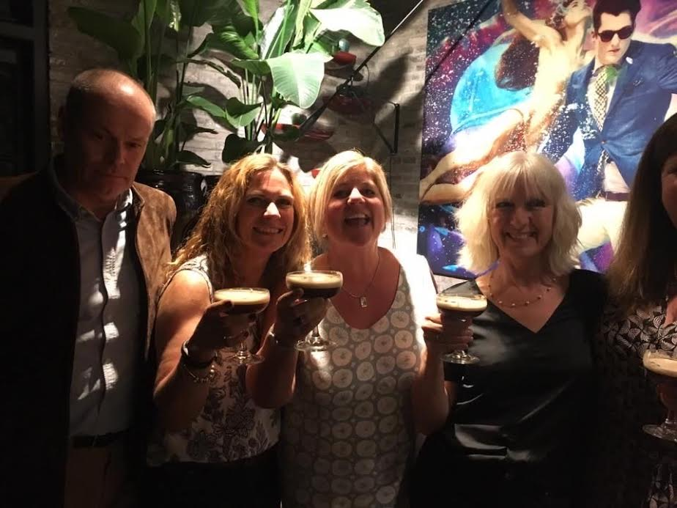
On a warm Saturday afternoon in June a group of Brits Abroad members got together to sample some of Shanghai’s local Gin. Peddlers Gin on Anfu Lu was the perfect location for this get-together. We started at about 4 o’clock with the classic Gin and Tonic which was very refreshing. We were then supplied with several Gin based cocktails - expertly mixed together by our dedicated barman. The Tom Collins went down very smoothly and helped everyone feel relaxed. The Negroni divided opinion with some loving it and others saying it wasn’t their favourite. We then had some cooked meats and cheeses provided by the local delicatessen to help soak up the alcohol. We finished the evening with a delicious Espresso Martini which everyone loved. We were even given the opportunity to mix our own which was great fun.
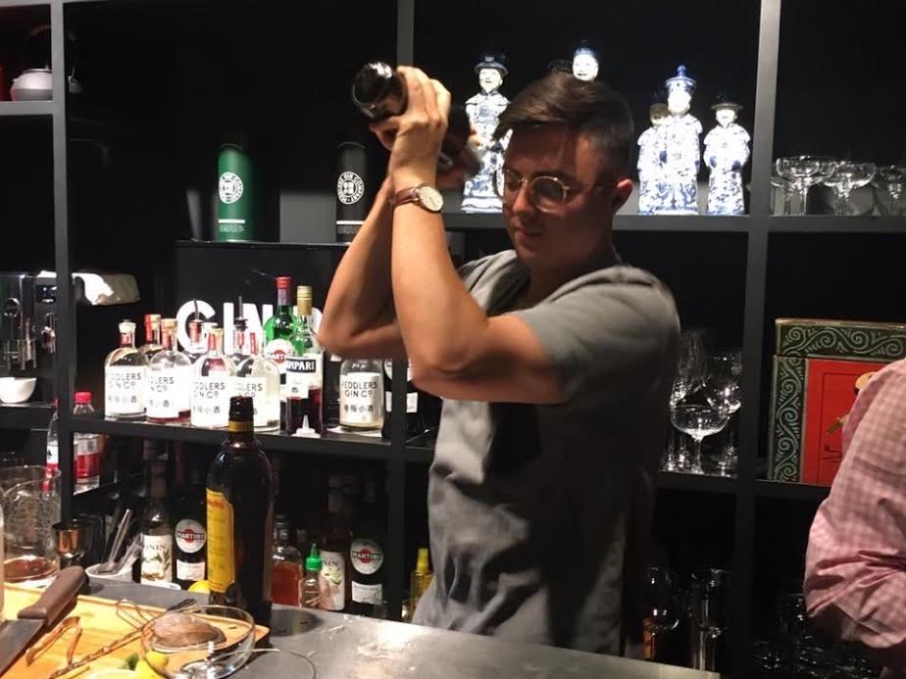

Gucun Park

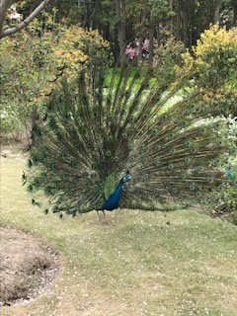
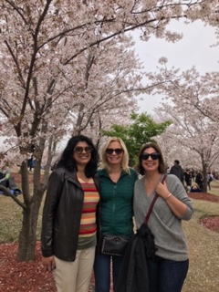
Come spring, Gucun Park is home to the largest cherry tree park in Shanghai with more than 10,000 cherry trees and it’s one of the best places to enjoy cherry and plum blossoms. We organised a special walk for our members to enjoy the blossoms in full bloom. The walk was run by Ginny Cunningham (our Ex-President) and once our members bought the entry tickets to the park they were able to enjoy spring in its full bloom. It was a beautiful to see all the various spring colours and to watch peacocks and parrots basking on a sunny day. The walk lasted about a couple of hours as we meandered our way through the park. The sights we saw were a treat to the eye. It was very popular with our members.

4. Regular Activities

Photography Club

Brits Abroad Photography Club, led by Sigrid and Emily, continued to run strong through its second year. Since April 2019, we’ve taken photos in lots of exciting places around Shanghai with visits to places such as the Long Museum, Shanghai’s Jewish Quarter, some of the International Hotels on the Bund to photograph the Christmas decorations and a day trip to Feng Jing water town. We also had fun with a ‘mini-studio’ session using light boxes to set up still-life shots and ‘product’ shots and were invited to take shots of guests having fun at the annual Brits Abroad ‘Think Pink’ lunch for breast cancer awareness.
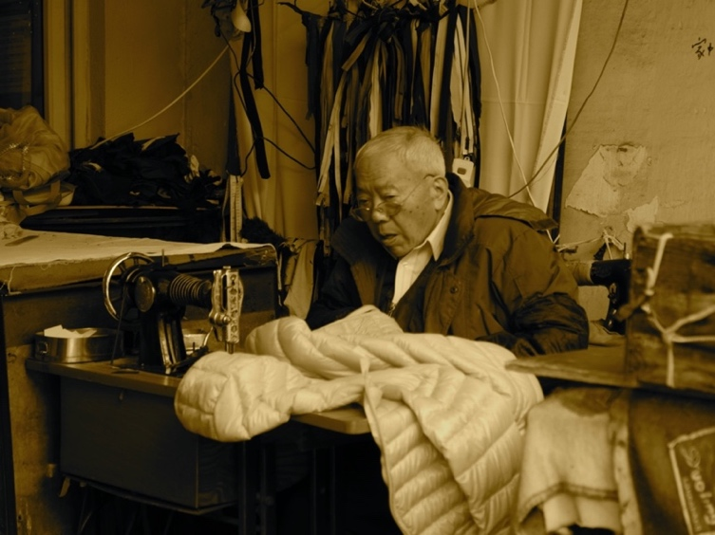
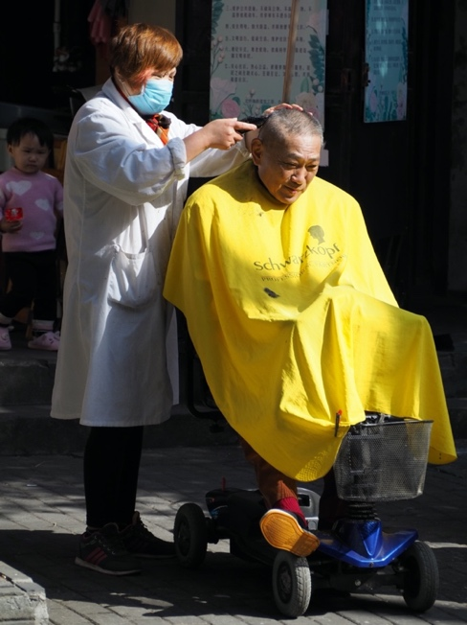
The club meets twice every month, usually on the 2nd and 4th Mondays of the month. During the first session of the month, we explore the streets of Shanghai taking photos and practicing a technical skill and a compositional skill. During the second session, we review our photos over a cup of tea and work out what we did well and what we could do better. The club is open to anyone who loves photography and wants to practice and improve – you need a camera but a point-and-shoot automatic or smartphone camera is as welcome as a professional grade DSLR! The purpose is to have fun sharing ideas, tips and tricks with a group of like-minded people.

Sigrid Brede & Emily Fereday
Photography Coordinators

May-I

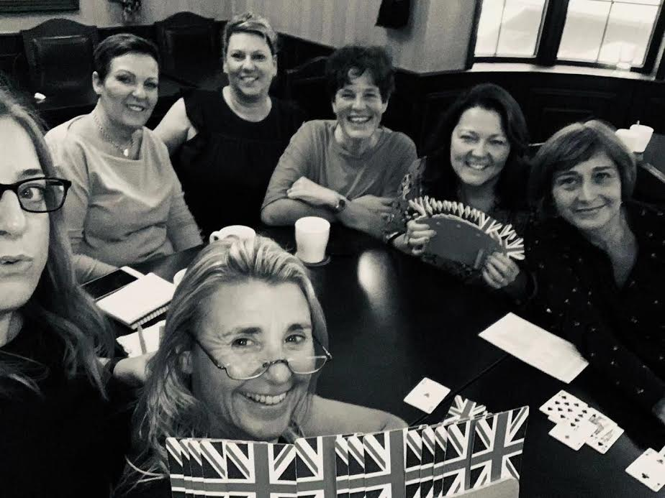
2019 was still a great success for the Wednesday afternoon May-I- activity. The numbers were still constant even though a lot of people had left Shanghai. Tracey Dhinsa and Gillian Drury who organised this activity in 2019 did a great job attracting newbies, to keep up this weekly gathering of around 20 people.
The Park Tavern is undergoing major construction which will change the venue into a restaurant. We are now happy to hold May-I at Abbey Road. A very nice substitution as the staff are pampering us weekly with great food and service.
May-I is a great way to meet fellow Brits Abroad members. Each week participants pick a card to determine on which table they will be playing. By picking cards, members play with different people each week allowing them to get better acquainted with fellow expats and forge new friendships. For only RMB 50, participants play cards for approximately 3 hours and receive two drinks – a choice of coffee, tea or soft drinks. Join us for a fun afternoon of May-I on Wednesdays!

Ilse Dumont
May-I Coordinator

Mahjong

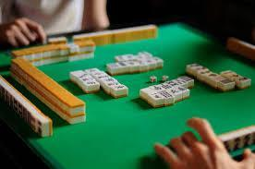
You’re in China so why not try your hand at Mahjong? Mahjong is a game that originated in China but is now played (in varying forms) all over the world. Like the Western card game rummy, Mahjong is a game of skill, strategy and calculation and involves a degree of chance… or it’s just a fun game for getting to know your fellow Brits Abroad members.
Every Monday afternoon (1:30pm – 4:30pm) we play the British version of Mahjong at Abbey Road on Taojing Road, at the corner of Fenjang Road. It’s a popular event and lots of fun. It’s open to everyone and is a great way to relax, chat and meet new people. We have a beginners' table every week so don’t worry about not knowing how to play. We only charge RMB 50 to play, which includes beverages for the afternoon and money for the charity pot. We have a lot of fun! Come join us!
Karen Carrington
Mahjong Coordinator

Walks
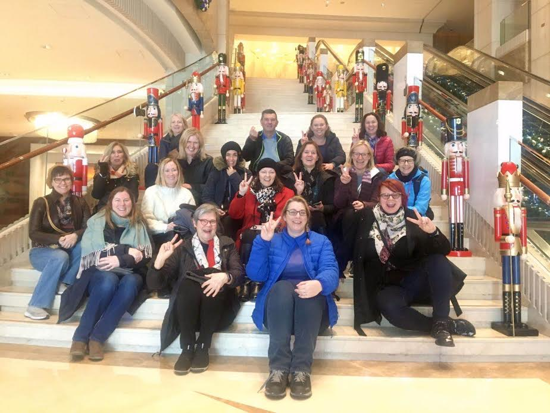
Our cultural walks have proven to be very popular and this year saw us strolling through a variety of cityscapes, from the gorgeous acres of cherry blossoms at Gucun Park to, not one, but two explorations of Shanghai's grimy and glamorous heyday. A late spring walk took us on a tour of the criminal, capitalist and entertainment hotspots featured in Paul French's City of Devils, and a follow-up walk in the autumn based on recommendations provided to us by the author himself, led us into the area once called The Badlands - places beyond the International Settlement boundaries where the law was vague and the nightclubs were hot.
As is traditional, we saw out 2019 with a wander along the classic hotels of the Bund to take in the magnificent holiday displays. We look forward to discovering many more
corners of this fascinating city in the coming months.

Kellie Henry
Walks Coordinator

Book Club
This is a club open to all members of Brits Abroad and can be joined at any time during the year. It has now moved to the third Wednesday of each month. The Club lost quite a few members this year due to repatriation and work commitments. However, we had several newcomers and currently have 11, 12 being our target.
This year members took turns again to host meetings in their homes. The host provided refreshments and a volunteer led the discussion. Meetings usually lasted one and a half hours. One extended meeting took place for the play Gaslight which included watching the second screenplay version, followed by a discussion of the book and film, plus lunch.
This year’s Book Club commenced in September 2019. Six books were chosen back in June. Books chosen during 2019-2020 included:
Love in the New Millenium by Can Xue; In the Shadow of the Banyan by Vaddey Ratner; Gaslight by Patrick Hamilton; Hullabaloo in the Guava Orchard by Kiran Desai; Becoming by Michelle Obama; and Free Food for Millionaires by Min Jin Lee.

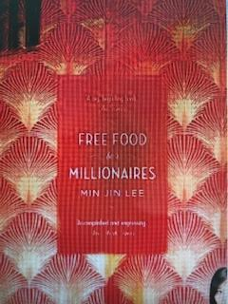
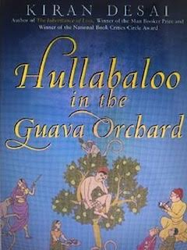
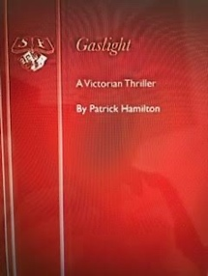
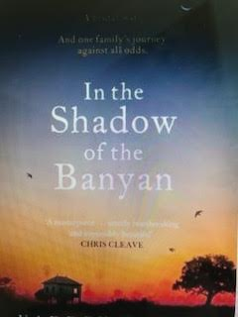
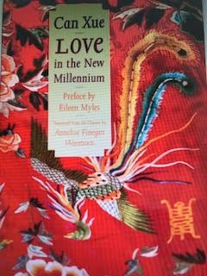
Further books were due to be chosen in February 2020 for the rest of the year, to take account of new members’ preferences. Naturally the February meeting was cancelled due to the Coronavirus and we are awaiting official permission to resume. At the next meeting, or by e mail if this is delayed beyond April, members will vote on the books to take us up to Christmas 2020, 15 nominations in all. Also, as the current Co-Chairs are shortly repatriating new volunteers are being sought.

Candia Allen & Catherine Hogan-Conlon
Book Club Coordinators

Quiz Night

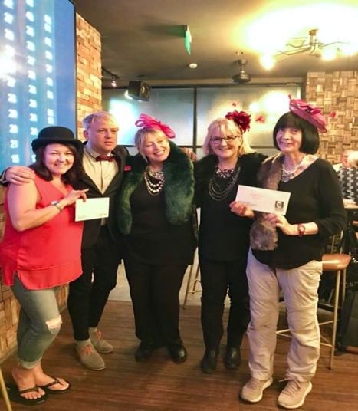
Our ever popular, monthly Quiz Night took up residence in The Camel this year and has proved to be a big success. The new venue allows more teams to participate, offers a wider food choice and their quizmaster, Ned, is responsible for creating all the multimedia quiz rounds. There have been five quiz nights – some with themed rounds to coincide with special dates such as Halloween, Christmas and St. Andrew’s Day.
The Camel also provides first and second place prizes - vouchers for some of their other restaurants in Shanghai, so the lucky winners can wine and dine to celebrate their success!

10k Any Day Walks
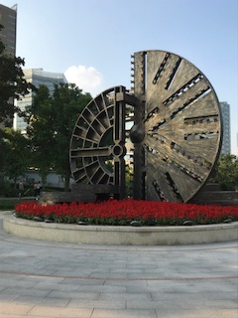
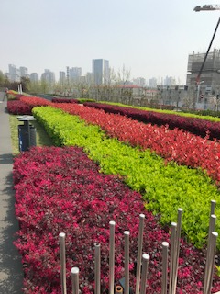
Our monthly 10k Any Day Walks have proved extremely popular with our members. They have included walks in the Jing’An District, walks along The Bund and several along the glorious Pudong Riverside Path. This Path is a purpose-built path with dedicated lanes for both cyclists and for joggers/walkers. The path has a special surface with a bit of ‘give’ in it so that it’s gentler on your joints. It’s an amazing facility and is well used throughout the day by locals and expats alike. 47km of pathway have been opened so far and there is always something interesting to see, whether that be people, sculptures, trees, flowers or boats. Our aim is to complete 10km within 2 hours. Simply sign up by the day before and you will be added to the WeChat Walk Group. Walkers can walk at their own pace and enjoy a catchup with fellow Brits members.

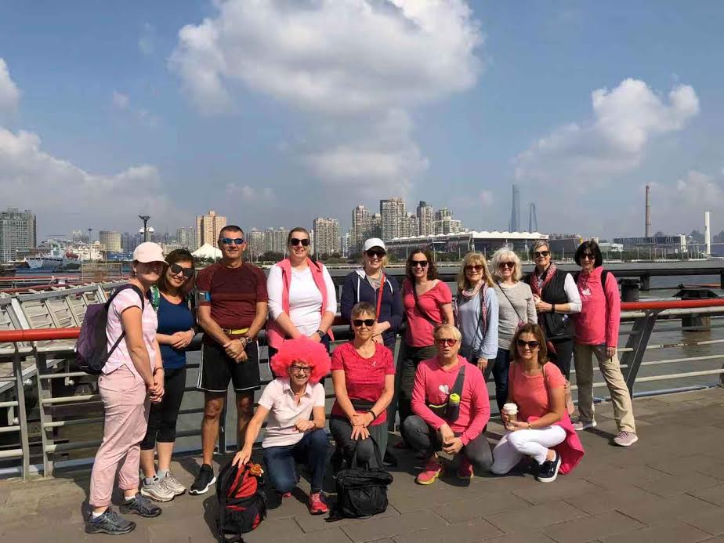
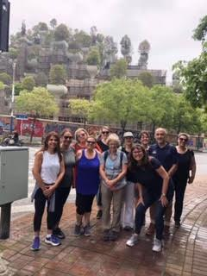

5. Community Outreach
The jewel in Brits Abroad’s crown is its Community Outreach programme. Every jiao Brits Abroad raises from events goes to various worthwhile organisations in China. Our donations in this financial year went to Shanghai Young Bakers, Shanghai Sunrise and Heart To Heart. In addition, the money raised in October at the Breast Cancer lunch and on the October walk has yet to be handed over, due to the Coronavirus restrictions, but as soon as we are able, we will present it to the charity ‘More Than Aware’. We also made donations to Indigo and Shanghai Baby’s Home which will be shown in the next financial year’s Accounts.
Shanghai Young Bakers trains and develops young people in the art of baking, preparing them for future careers in the hospitality industry. The program is targeted at young people who are doing less well at school.
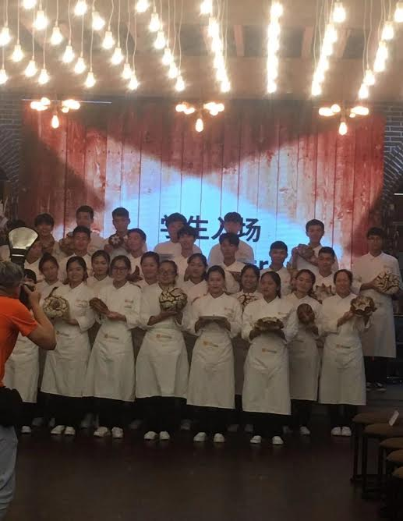
This year’s batch of trainees

We sponsor 4 Shanghai Sunrise students at an annual cost of RMB 3,000 each. 3 of the students are in secondary education and the 4th is at university. Our President attended the annual presentation lunch and was able to see first-hand the work this charity does for disadvantaged students from across China who have been given the opportunity to study in mainstream education in Shanghai for the final 4 years of school. Our university student is in his 3rd and final year and hopes to graduate in late summer 2020. Our total sponsorship in the academic year came to RMB 12,000.
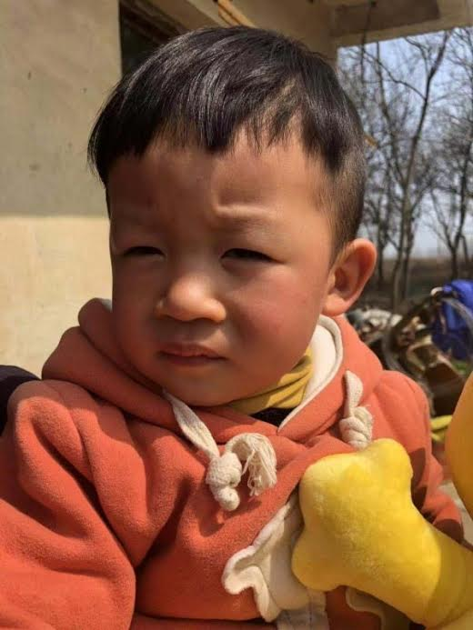
Heart To Heart is a charity which provides much-needed heart surgery and follow-up support to children. Our RMB 15,000 Ascot lunch donation allowed this charity to give 4 urban schools, much-needed sports equipment, including children who have received care and heart surgery in the past. Our Christmas party raised RMB 12,100 (to be topped up, but the amount is not yet decided) which we also donated to the charity to support children who have had heart surgery, to contribute towards the care they receive during their time in hospital. We also collected gifts and clothing at the party which Heart To Heart distributes to families who live in harsher climates, to enable them to keep their children warm in winter.
We received word that this little boy, who we helped in 2017, is now 3 years old and thriving.

More than Aware is a Shanghai-born support group that has been empowering women to be proactive in the prevention and recovery of breast cancer since 2011. The staggering amount of RMB 35,000, raised at the breast cancer lunch, will be donated to this charity when coronavirus restrictions are lifted.

Our focused charities for 2020/21 are Shanghai Baby’s Home, Indigo, Heart To Heart, breast cancer and Shanghai Sunrise.

Indigo is a charity which supports adults with learning difficulties. They run a day centre which gives attendees the opportunity to enjoy activities such as arts and crafts.

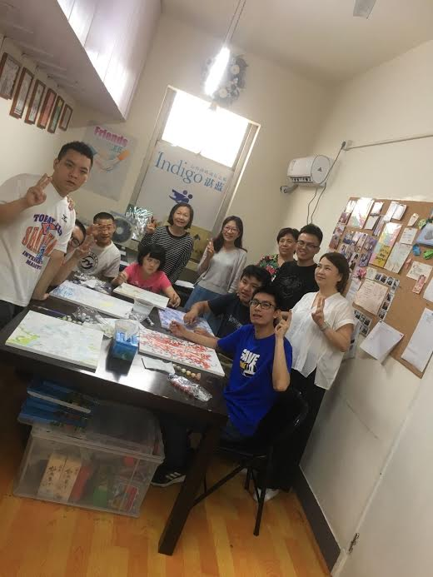

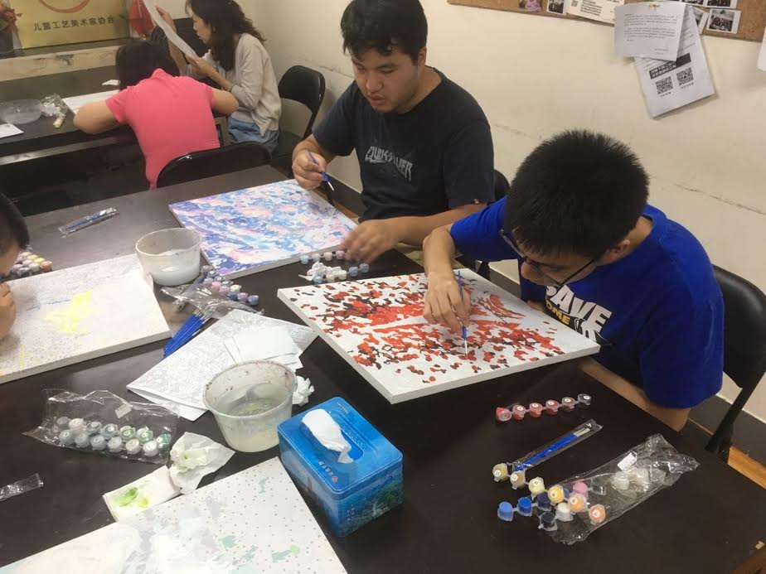
Attendees at the Indigo Day Centre enjoying art and craft activities

Shanghai Baby’s Home is a charity which provides care and rehabilitation for orphaned babies and young children, after they have had surgery to correct things like cleft lips and palates. Their ultimate goal is to get the children adopted into loving homes, where they can live a healthy, happy life.

Here are the charities links:
www.shbabyhome.org.cn
www.h2hsh.com
www.shanghaiyoungbakers.com
www.morethanaware.com
www.shanghaisunrise.com

The total amount Brits Abroad raised in 2019/20 was RMB 96,100. THANK YOU to everyone for this fabulous achievement. You have helped so many children, young people and adults.

6. Internal and External Communications

The introduction of the Brits Abroad app has been a great success and allows our members to view upcoming events and activities and manage their sign up and attendance. Members can also update their personal information such as address and phone number.

There are many ways in which we hope that we keep you informed about what’s happening with Brits Abroad and there are a range of ways in which you can keep in touch with us. In addition to our weekly bulletin and monthly “Wire” publication, there are of course the Brits Abroad Website and our Hotmail account. And if you are a Facebook user, we hope that Brits Abroad is one of your Facebook friends.
Finally, don’t forget our members’ request facility. Members are encouraged to use this feature to ask help from fellow Brits Abroad members. All you need to do is fill in the form on the website and we’ll post your request in our weekly bulletin. For specific enquiries or to contact the committee, please use our Hotmail account: britsabroad57@hotmail.com. Just put a description of your enquiry in the subject line to direct it to the appropriate person.
7. Financial Report
BRITS ABROAD SHANGHAI FINANCIAL STATEMENT
FOR THE YEAR ENDED 31ST DECEMBER 2019
INCOME & EXPENDITURE ACCOUNT
FOR THE YEAR ENDED 31ST DECEMBER 2019
RMB
INCOME
May-I 39,310.00
Mahjong 13,670.00
Special Events 87,451.00
Quiz 3,390.00
Membership 40,300.00
Walks 5,840.00
Donations 450.00
Yoga 850.00
Vendors 800.00
---------------
192,061.00

EXPENSES
May-I 23,830.00
Mahjong 8,190.00
Special Events 34,433.19
Volunteer drinks 1,281.00
Admin 1,659.76
Tea at the Kee 4,110.00
Charity Donations 61,100.00 134,603.95
--------------- ---------------
EXCESS OF INCOME OVER EXPENDITURE 57,457.05
=========

BALANCE SHEET 31/12/2018 31/12/2019
RMB RMB
Bank/Safe 93,000.00 156,500.00
WeChat Pay - 13,579.05
Cash 25,699.00 6,077.00
--------------- ---------------
TOTAL ASSETS 118,699.00 176,156.05
========= =========

NET INCREASE 57,457.05

DONATIONS
RMB
Shanghai Young Bakers (2018) 25,000.00
Shanghai Sunrise 9,000.00
Heart To Heart (Ascot lunch) 15,000.00
Heart To Heart (Christmas lunch) 12,100.00
Breast Cancer (October lunch) -
(still to be donated)
--------------
61,100.00
========

We have had a successful year which resulted in a surplus of RMB 57,457.05, after making donations of RMB 61,100. We started using WeChat Pay which makes recording all financial movements easier. We also don’t have to use cash anymore for most events and transactions.
The money collected in October for “More than Aware” Breast Cancer charity is still to be handed over (RMB 35,000). The handover was originally planned for February, but due to the Coronavirus it was postponed to 12th March. Regarding the Christmas donation to H2H, the committee decided to top up the amount of RMB 12,100. The final amount has still to be decided.
The Balance Sheet is very healthy, we have net assets of RMB 176,156.05.

Christel Adriaenssen - Treasurer

8. Public Relations & Marketing

Brits Abroad very much deserves the excellent reputation it has amongst the expat communities in Shanghai. We have continued during 2019 to promote Brits Abroad to new members, sponsors and the wider community. In addition to running a stand at the 2019 Expat show, we have also been present at international school events, introducing Brits Abroad to new audiences whilst celebrating our work with established members too.
Many of our members have attended British themed activities and events in Shanghai, including the British Chamber’s St. Patrick’s Ball and St. Andrew’s Ball.

9. The Brits Abroad Team

The Committee members and representatives who served during 2019/20 are set out below:

The Committee

President Ginny Cunningham (Mar. ‘19 – Jun. ‘19)
Selina Ruscoe-Price (Jun. ’19 – Mar. ’20)
Vice President Selina Ruscoe-Price (Mar. ’19 – Jun. ’19)
Melissa Blissett & Marysia Trebley
(jointly Jun. ’19 to Mar. ’20)
Treasurer Christel Adriaenssen
Secretary Emma Dilliway
Social Coordinator Bonita Frost
Membership Secretary Anita Aggarwal
Community Outreach Coordinator Marysia Trebley
The Wire Editor Melissa Blissett
Website Coordinator James Dyson
Public Relations /Advertising Vidhya Nagendran
Discounts Coordinator Caz Johnstone

The Representatives

Walks Coordinator Victoria van de Putten (Mar. ’19 - Oct. ‘19)
Kellie Henry (Oct. ‘19 - Mar. ’20)
Book Club Coordinators Candia Allen & Catherine Hogan-Conlon
Mahjong Coordinator Karen Carrington
May-I Coordinator Tracy Dhinsa (Mar. ’19 to Oct. ’19)
Ilse Dumont (Oct. ’19 – Mar. ’20)
Proofreader Pam Gray

Together with the above, Brits Abroad are lucky to have a host of other volunteers who give their time, energy, enthusiasm and advice and help make the Brits Abroad community a welcoming, active and fun place to be. Without the help of all of the above people, many events and activities would not be able to continue – thank you.

